Investment Proposal: 300 MW Solar Photovoltaic Power Plant in Nicaragua

1. Executive Summary
This document presents a compelling investment opportunity for the development, construction, and operation of a 300 MW utility-scale solar photovoltaic (PV) power plant in Nicaragua. Project “Sol de Nicaragua” is strategically positioned to capitalize on the nation’s excellent solar resources, supportive government policies, and growing demand for clean, cost-effective energy. The project is underpinned by a guarantee from the China Export & Credit Insurance Corporation (Sinosure), significantly mitigating investment risks.
The project requires the exclusive use of high-efficiency inverters from Huawei Technologies, a global leader in smart PV solutions, ensuring optimal performance and long-term reliability. With an estimated total EPC cost of USD 350 million, the project is projected to generate approximately 450 GWh of clean electricity annually. This output will displace expensive, imported fossil fuels, contributing to Nicaragua’s energy security and sustainability goals.
Direct engagement with the highest levels of the Nicaraguan government has been secured, ensuring a streamlined development process. The project offers attractive financial returns, driven by a competitive power purchase agreement (PPA) with the national utility, and aligns with the country’s ambitious renewable energy targets. This proposal details the project’s strong financial viability, technical feasibility, and strategic importance, making it a premier investment in Central America’s renewable energy sector.

Investment Highlights
Metric | Value | Description
Project Capacity | 300 MWp | Significant addition to Nicaragua’s generation capacity.
Annual Generation | 450 GWh | Reliable, clean energy to power the nation.
Total EPC Cost | USD 350 Million | Competitive cost based on local market benchmarks.
Technology | Huawei Inverters | World-class technology for maximum efficiency and reliability.
Government Support | High-Level Engagement | Direct access to key decision-makers for smooth execution.
Risk Mitigation | China Sinosure Guarantee | Comprehensive insurance coverage for political and commercial risks.
Market Opportunity | High Growth Potential | Tapping into an underserved market with strong demand for renewables.

2. Introduction
Nicaragua is at a pivotal moment in its energy transition. With a growing economy and a national mandate to increase its share of renewable energy, the country presents a fertile ground for large-scale solar investments. Project “Sol de Nicaragua” is a direct response to this opportunity, a landmark 300 MW solar PV initiative designed to deliver substantial economic and environmental benefits.
The project has received preliminary endorsement from the Nicaraguan government, with confirmed access to the President and relevant ministries to facilitate negotiations and approvals. This high-level political backing is a cornerstone of the project’s de-risking strategy. Furthermore, the commitment from China Sinosure to provide a comprehensive guarantee provides investors with an exceptional level of security against potential political and commercial risks, making this a uniquely secure investment in the region.
The mandatory use of Huawei’s state-of-the-art solar inverters ensures that the plant will operate at peak performance, leveraging advanced features like AI-powered diagnostics and smart O&M to maximize energy yield and minimize operational costs. This report outlines the project’s technical solution, financial projections, and the compelling case for its role in shaping a sustainable energy future for Nicaragua.

3. Nicaragua’s Energy Market Analysis
Nicaragua’s energy sector is characterized by a high dependence on imported fossil fuels, relatively high electricity tariffs, and a significant, untapped potential for renewable energy. This landscape creates a strong imperative for the development of projects like the 300 MW solar plant.

3.1. Current Electricity Landscape
In 2023, Nicaragua’s total electricity generation was approximately 4,525 GWh, with an installed capacity of 1,850 MW [1]. The country’s power generation mix is dominated by oil, which accounts for 37.5% of the total. While the share of renewables is significant at over 60%, the contribution from solar PV is a mere 0.6%, highlighting a substantial opportunity for growth [1].
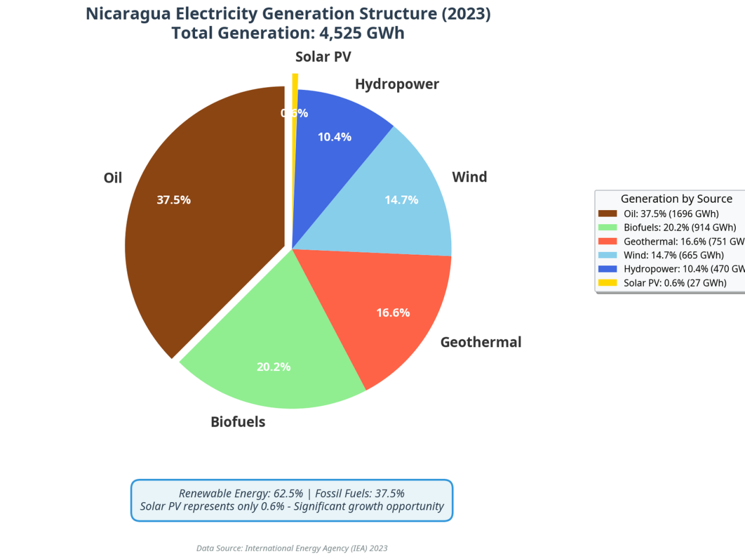 Figure 1: Nicaragua’s electricity generation mix in 2023, showing a heavy reliance on oil and minimal solar PV contribution. Source: IEA [1]

3.2. Government Policy and Tariffs
The Nicaraguan government is actively promoting renewable energy to reduce its reliance on volatile fossil fuel markets and to meet its climate objectives. The country has set a target to increase its renewable energy share to over 80% in the coming years [2].
Key policies supporting this project include: - Law No. 532: Provides tax incentives for investments in renewable energy projects. - Feed-in Tariffs (FiT): The government has established a FiT mechanism to encourage renewable energy deployment, with rates for clean energy sources cited at a competitive USD 0.07 per kWh [3]. This is significantly lower than the cost of generation from thermal plants, which stands at USD 0.15 per kWh [3]. - Power Purchase Agreements (PPAs): The national utility, ENATREL, is authorized to sign long-term PPAs with independent power producers, providing a stable revenue stream for projects.

3.3. The Case for Solar in Nicaragua
With an average solar irradiation of 5.0-5.5 kWh/m²/day, Nicaragua possesses some of the best solar resources in Central America [4]. The development of a 300 MW solar plant would have a transformative impact: - Displacement of Fossil Fuels: The plant’s 450 GWh annual output would directly displace expensive electricity generated from imported oil, saving the country millions in foreign exchange. - Energy Security: It would increase Nicaragua’s energy independence and resilience to global oil price shocks. - Cost Reduction: Solar power is now cheaper than thermal generation in Nicaragua, and the project will help lower the overall cost of electricity for consumers and businesses.

4. Project Description & Technical Solution
Project “Sol de Nicaragua” is designed to be a state-of-the-art solar power facility, engineered for high efficiency, reliability, and a long operational life.

4.1. Project Overview
- Capacity: 300 MWp (DC)
- Location: A suitable site with high solar irradiation and proximity to grid infrastructure will be selected in coordination with the Nicaraguan government. The Pacific coastal plains are a prime candidate region.
- Land Area: Approximately 600-700 hectares.
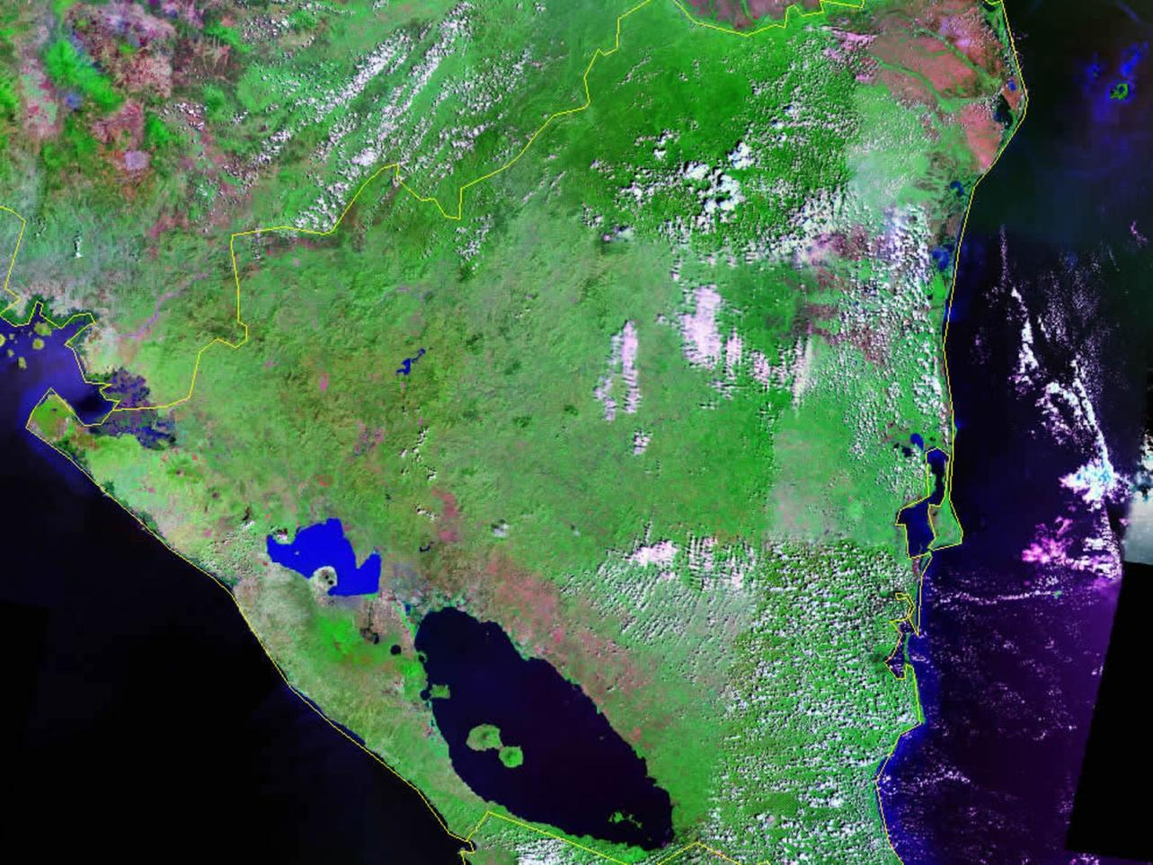 Figure 2: Satellite map of Nicaragua, highlighting its geography and potential for large-scale solar development. Source: Geology.com [5]

4.2. Technical Specifications
The plant will be built using Tier 1 components to ensure maximum performance and durability.
Component | Specification
PV Modules | High-efficiency monocrystalline PERC or TOPCon modules (~550Wp)
Inverters | Huawei FusionSolar Smart String Inverters (SUN2000-215KTL-H1)
Mounting System | Fixed-tilt or single-axis tracker ground-mounted system
Grid Connection | 138 kV overhead transmission line to a nearby ENATREL substation

4.3. Huawei Inverter Solution
The mandatory use of Huawei inverters is a key technical advantage. Huawei’s FusionSolar solution offers a suite of intelligent features that lower the Levelized Cost of Energy (LCOE) and enhance operational efficiency: - Higher Yields: With up to 99% efficiency and multiple MPPTs, the inverters maximize energy capture even in complex conditions. - Smart O&M: AI-based I-V curve diagnosis and proactive fault detection reduce maintenance costs and downtime. - Proven Reliability: The fan-less, natural cooling design and IP66 rating ensure high availability and a long service life, even in harsh environments. - Grid Support: Advanced grid-forming capabilities provide stable power and support the national grid.

4.4. Construction Timeline
The project is expected to be completed within a 24-month timeframe from financial close. - Phase 1 (6 months): Final permits, detailed engineering, and procurement. - Phase 2 (18 months): Site preparation, construction, installation, and commissioning.

5. Financial Analysis
Project “Sol de Nicaragua” presents a robust financial case with attractive returns for investors, secured by long-term revenues and a strong risk mitigation package.

5.1. Project Costs
The total estimated project cost is broken down as follows:
Cost Component | Amount (USD) | Notes
EPC Cost | $350,000,000 | Based on a rate of $1.17/Wp, benchmarked against recent projects in the region [6].
Development & Other Costs | $25,000,000 | Includes land acquisition, permits, legal, and financing costs.
Contingency | $25,000,000 | 7% of total costs.
Total Project Cost | $400,000,000

5.2. Revenue Projections
Revenue will be generated through a 20-year PPA with ENATREL.
- Annual Generation: 450,000,000 kWh (450 GWh)
- PPA Tariff: Assuming a competitive tariff of $0.07/kWh, in line with the government’s stated cost for clean energy [3].
- Annual Revenue: $31,500,000

5.3. Operating Expenses
Expense Item | Annual Cost (USD) | Notes
O&M | $2,100,000 | Based on an estimate of $7/kWp/year.
Insurance | $1,000,000 | Comprehensive coverage.
Land Lease & Other | $400,000
Total Annual Opex | $3,500,000

5.4. Financial Metrics
Based on the assumptions above, the project’s key financial indicators are highly attractive.
Metric | Value | Interpretation
Levelized Cost of Energy (LCOE) | ~$0.045/kWh | Highly competitive, well below current business tariffs and thermal generation costs.
Project IRR (Unlevered) | ~9.5% | Strong return before considering leverage.
Equity IRR (Levered) | ~15-18% | Assuming a 70/30 Debt/Equity financing structure.
Payback Period | ~8-10 years | Quick return of initial investment.

5.5. Financing and Sinosure Guarantee
The project is ideally suited for a project finance structure with a 70% debt and 30% equity split. The China Sinosure guarantee will be instrumental in securing favorable debt financing terms. This guarantee covers both political risks (e.g., expropriation, currency inconvertibility) and commercial risks (e.g., PPA default), providing a comprehensive safety net for both debt and equity investors.

6. Risk Analysis and Mitigation
A thorough risk assessment has been conducted, with clear mitigation strategies for each identified risk.
Risk Category | Description | Mitigation Strategy
Political Risk | Changes in government policy or political instability. | Sinosure guarantee; Strong government agreements; High-level political support.
Construction Risk | Cost overruns or delays. | Fixed-price, date-certain EPC contract with a reputable contractor.
Operational Risk | Lower-than-expected plant performance. | Use of Tier 1 components (Huawei inverters); Comprehensive O&M plan; Performance guarantees from EPC.
Revenue Risk | PPA default or tariff reduction. | Sinosure guarantee covering PPA obligations; Long-term, fixed-price PPA with the national utility.
Currency Risk | Devaluation of the Nicaraguan Córdoba. | PPA tariff to be denominated in or indexed to USD.

7. Conclusion
Project “Sol de Nicaragua” represents an exceptional opportunity to invest in a large-scale, high-return renewable energy project in a supportive and high-growth market. The combination of excellent solar resources, strong government backing, a secure revenue stream via a long-term PPA, and the unparalleled risk mitigation provided by the China Sinosure guarantee makes this a uniquely attractive and secure investment.
We are confident that this 300 MW solar plant will not only deliver significant financial returns to its investors but will also play a crucial role in advancing Nicaragua’s economic and sustainable development goals. We invite you to partner with us in bringing this landmark project to fruition.

