Investment Proposal: 30MW Solar PV Power Plant in Chile

Executive Summary
This report details a compelling investment opportunity to develop, construct, and operate a 30 MW solar photovoltaic (PV) power plant in the Atacama Desert region of Northern Chile. This project represents a secure and highly profitable venture, capitalizing on Chile’s exceptional solar resources, stable regulatory environment, and strong government support for renewable energy. The project’s bankability is significantly enhanced by a comprehensive guarantee from the China Export & Credit Insurance Corporation (Sinosure), mitigating political and commercial risks for investors.
A key feature of this project is the exclusive use of high-efficiency inverters from Huawei, a global leader in smart PV technology, ensuring optimal performance and reliability. The total Engineering, Procurement, and Construction (EPC) cost is estimated at USD 30 million, based on current market data for utility-scale solar projects in Latin America.
Revenue will be secured through a long-term Power Purchase Agreement (PPA), with pricing expected to be highly competitive, referencing recent national auctions where prices have ranged from USD 38/MWh to over USD 70/MWh [1]. This, combined with the region’s world-class solar irradiance, promises a robust and attractive return on investment. Furthermore, the project sponsors have secured high-level access to the President of Chile and relevant government ministries, ensuring streamlined development and operational phases.

1. Investment Highlights
Highlight | Description
Favorable Market | Chile’s stable, mature energy market is actively phasing out coal and targeting 70% renewable generation by 2030, creating strong demand for new solar capacity [2].
World-Class Solar Resource | The project will be located in the Atacama Desert, which boasts the highest solar irradiance levels on Earth, with a Direct Normal Irradiance (DNI) of up to 3,800 kWh/m²/year, maximizing energy yield and revenue [3].
Sinosure Guarantee | Full project security is provided by Sinosure, China’s official export credit agency, which insures against a wide range of political and commercial risks, making this a de-risked investment [4].
High-Level Government Support | Direct access to the highest levels of the Chilean government has been established, facilitating smooth negotiations, permitting, and long-term operational stability.
Proven Tier-1 Technology | The project mandates the use of Huawei’s smart string inverters, renowned for their 99% maximum efficiency, reliability, and advanced smart O&M capabilities, guaranteeing superior plant performance [5].
Attractive Financial Returns | A combination of low EPC costs, exceptional solar resources, and strong PPA pricing creates the foundation for a highly attractive internal rate of return (IRR) and a secure, long-term revenue stream.

2. Chile’s Energy Market & Regulatory Framework

2.1. Current Electricity Market
Chile is a regional leader in the transition to clean energy. As of 2025, renewables already account for over 63% of the country’s total power generation. The government’s aggressive decarbonization strategy, which includes the closure of two-thirds of its coal-fired power plants by 2025, further solidifies the demand for utility-scale solar projects.
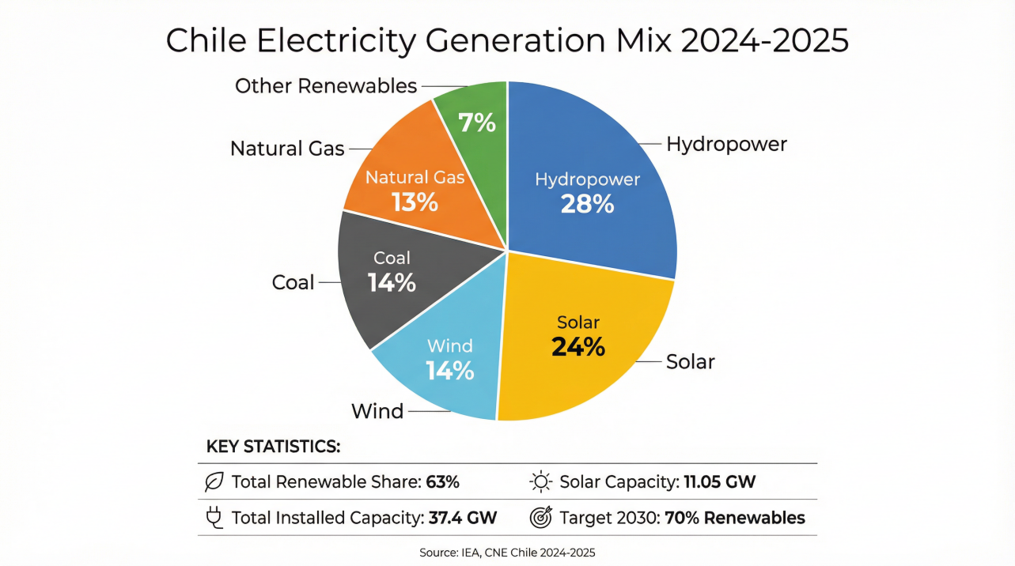 Figure 1: Chile’s diverse and increasingly green electricity generation mix. [2]

2.2. Government Policy and Support
The Chilean government’s Long-Term Energy Policy (PELP) provides a clear and stable roadmap for investors. It establishes a national goal of achieving net-zero emissions by 2050 and encourages foreign investment in the renewable energy sector through transparent regulations and a competitive auction system for PPAs. This commitment provides long-term certainty for project developers and financiers.

2.3. Power Purchase Agreements (PPA) & Revenue
The primary revenue stream for the project will be a long-term PPA with a creditworthy offtaker, awarded through the national auction process. The results of the most recent supply tender in late 2025 demonstrate a healthy pricing environment, with bids ranging from USD 38/MWh to USD 120/MWh, and average prices settling between USD 60/MWh and USD 80/MWh depending on the time block [1]. These prices provide a strong basis for projecting the project’s profitability.

3. Project Location & Solar Resource

3.1. Project Location
The proposed project site is in the Atacama Desert in Northern Chile. This region is globally recognized as the optimal location for solar power generation due to its unique atmospheric and geographic conditions. It is also in proximity to major mining operations and the national interconnected grid, ensuring demand and offtake infrastructure.
 Figure 2: Satellite image of the arid Atacama Desert region in Northern Chile, the proposed project location. [6]

3.2. Solar Irradiance Analysis
The Atacama Desert possesses the highest solar resource in the world. The site benefits from:
- Exceptional Irradiance: Annual GHI values exceed 2,600 kWh/m² and DNI values reach up to 3,800 kWh/m² [3].
- Clear Skies: The region experiences minimal cloud cover and precipitation year-round.
- High Altitude & Low Humidity: These factors increase the intensity of solar radiation reaching the surface.
These conditions are projected to yield a capacity factor between 25% and 30%, significantly higher than the global average for solar PV projects, directly translating to higher energy production and revenue.

4. Technical Proposal

4.1. Project Overview
- Capacity: 30 MWac
- Technology: Photovoltaic (PV)
- Location: Atacama Desert, Chile
- Inverter: Huawei Smart String Inverter (SUN2000 series)
- Grid Connection: Connection to Chile’s National Electric System (SEN)

4.2. Key Component: Huawei Inverters
The project will exclusively utilize Huawei’s utility-scale smart string inverters. This choice is based on their market-leading technology and proven performance in harsh environments. Key advantages include:
- High Efficiency: A maximum efficiency of 99.0% and multiple MPPTs (6 per unit) minimize mismatch losses and maximize energy yield [5].
- Reliability: A fanless, natural cooling design and an IP65 protection rating ensure a long operational life with minimal maintenance, even in desert conditions.
- Smart O&M: Integrated Smart I-V Curve Diagnosis allows for remote, automated plant monitoring and fault detection, significantly reducing operational expenditure (OPEX).

4.3. Estimated Performance
Based on the superior solar resources and high-efficiency components, the plant is expected to generate approximately 72,000 MWh of clean energy annually.

5. Financial Analysis

5.1. EPC Total Cost (CAPEX)
Drawing on recent benchmark data for utility-scale projects in the region, the all-in EPC cost is estimated to be USD 1.00 per watt, resulting in a total capital expenditure of USD 30 million [7].
Cost Component | Estimated Percentage
Solar Modules | 30-35%
Huawei Inverters | 8-12%
Mounting Structures & BOS | 20-25%
Civil Works & Installation | 15-20%
Grid Connection & Substation | 5-10%
Engineering & Development | 5-8%
Contingency | 5-8%

5.2. Revenue Projections
Assuming a conservative average PPA price of USD 55/MWh, the project is projected to generate annual revenues of approximately USD 3.96 million.

5.3. Project Security with Sinosure
China Export & Credit Insurance Corporation (Sinosure) will provide a comprehensive insurance policy for the project. This guarantee is a cornerstone of the investment’s security, offering protection against a broad spectrum of risks:
- Political Risks: Including expropriation, war, currency inconvertibility, and breach of contract by government entities.
- Commercial Risks: Including payment default by the offtaker.
Sinosure has a strong track record in Latin America and has previously signed framework agreements with Chilean banks to support Chinese-led EPC projects in the country [4]. This backing significantly enhances the project’s creditworthiness and secures the investment against unforeseen events.

6. Conclusion
The 30MW Chilean Solar PV Project offers a rare combination of low risk and high return. It is anchored by the world’s best solar resources, a stable and supportive policy environment, and the unparalleled security of a Sinosure guarantee. The strategic selection of Huawei’s leading technology ensures maximum energy yield and operational efficiency. With direct high-level government access and a clear path to profitability, this project represents a premier opportunity for investors seeking to enter the lucrative Latin American renewable energy market.

