50MW Onshore Wind Project

in Dominican Republic
Summary.
FT Energy Partners, LLC (“FT Energy”) has acquired the rights to a 50MW wind project, Jasper Caribbean Windpower LLC (“Jasper”), in Puerto Plata, Dominican Republic. Jasper has concessions for a total of 115MW in two phases, with the first phase being 50MW. All permits for the first phase 50MW were previously issued and a PPA was signed in November 2019. However, the prior developer and sponsor were not able to secure project financing, and as a result they could not start construction on time and the PPA was rescinded in February 2020 by the DR government.

In October 2020, the DR Ministry of Energy asked FT Energy to step in as sponsor to develop the Jasper project, and assured FT Energy that the DR government would issue a new PPA if FT Energy could commit to executing and obtaining financing. Thus, FT Energy became the new sponsor for Jasper and has worked since the end of 2020 to maintain and renew all required permits and to negotiate a new PPA.

In July 2025, the Unified Council for Distribution Companies – CUED (Consejo Unificado de las Empresas Distribuidoras, https://cued.gob.do) offered us a new PPA for 15 years at US$0.0995/kWh for the first 75% of the energy produced and the remaining 25% of the energy is paid according to spot market prices. CUED is the government agency that signs all PPAs.

All PPA contract terms were agreed to in December 2025. CUED requires us to sign the PPA by end of January to mid-February 2026.

The average electricity spot market price for 2023 was $0.1301/kWh, 2024 was $0.1232/kWh, and 2025 was $0.1198/kWh.
DR laws stipulate that renewable energy must be consumed before conventional /fossil fuel energy, regardless of PPA status, and currently renewables account for about 10-15% of the total energy usage. The DR government is committed to expanding its use of renewable energy and is moving forward with renewable projects.

The DR continues to experience daily power outages. The World Bank estimated that DR’s large and expanding gap in electricity supply was 2GW of generating capacity, compared to an installed base of 5 GW. Fossil fuels which account for ~75% of generating capacity.

In February 2024, FT Energy and the shareholders of Jasper agreed to sell the project to a publicly traded renewable energy company called Ecoener, S.A., based in Spain, https://www.ecoener.es/en. Ecoener has until January 15, 2026, to complete the transaction. However, as end of December 2025, they have not secured financing yet. If Ecoener does not achieve financial closing by January 15, 2026, their rights are forfeited, and the projects rights will revert to FT Energy.

The P50 wind capacity factor (CF) for the project is estimated at 38% (3320 hours) at 225m tip height using Vestas 5.6MW turbines, or 166 GWh/year first year energy production. P75% wind CF is 29.1% (2549 hours) or 127 GWh/year.

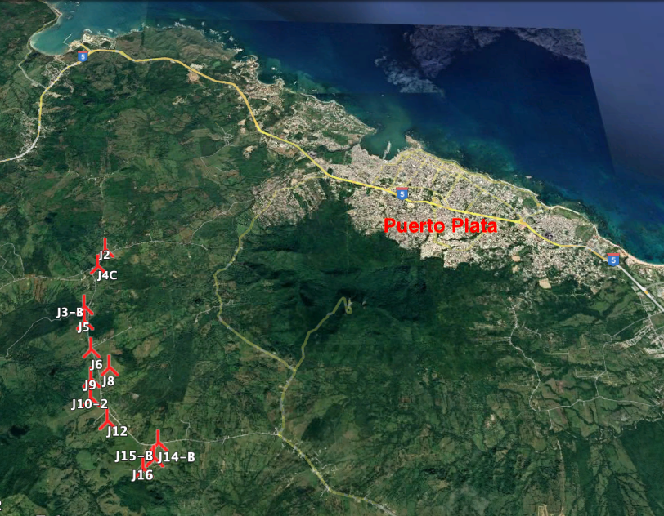
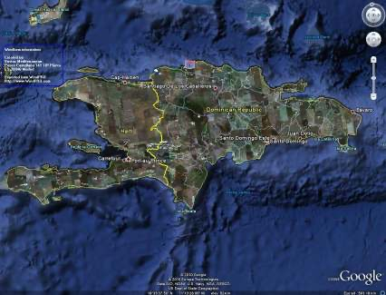

PPA Status.
A new PPA has been agreed to in December 2025:
- PPA price is US$0.0995 US cents/kWh for the first 75% of the energy produced by the wind project, and the remaining 25% of the energy will be paid according to spot market.
- CUED wants us to sign PPA as soon as possible – by end of January or mid-February 2026.
- To sign the PPA, a $4 million bond must be submitted at the time of signing the PPA contract.
- After signing the PPA, construction must start within 6 months and achieve COD within 24 months without penalty.

Permit Status.
All permits, including EPA (environmental) and ETED (grid connection), and definitive concessions have been received and are in good standing.
Grid connection point is less than 2km.

Land Status.
All land lease agreements for the wind turbine towers and grid connection route are ready to be signed; the lease price is $1,500/tower/month,
The land for the step-up station must be purchased according to law, and the price is $350,000.

Estimated Project Milestone Schedule:
December 2025 PPA price and terms have been agreed to with CUED.
February 2026 Sign PPA
August 2026 Start of construction: starting the foundation for the on-site step station is considered start-of-construction.
July 2028 We have two years to achieve COD date without paying penalties.

Financial Projections. Using P50 wind CF of 38% (3329 hours) with first year energy production of 166 GWh, unlevered IRR is 21%. At P75 wind CF of 29.1% (2549 hours), the unlevered IRR is 14.25%. We assume step-up station costs $7.5 million, shipping (ocean and inland) is $8 million, and the remaining EPC cost is $32.5 million (based on Chinese turbines).

