Investment Proposal: Nicaragua Nationwide Traffic Violation Monitoring System

Executive Summary
This report presents a comprehensive investment proposal for a nationwide traffic violation monitoring system in Nicaragua, structured as a Public-Private Partnership (PPP) with a 10-year revenue-sharing agreement. The project offers an exceptional investment opportunity, combining high profitability with robust security through a guarantee from the China Export & Credit Insurance Corporation (SINOSURE). The total Engineering, Procurement, and Construction (EPC) investment is estimated at $60 million USD, which will fund the deployment of 1,000 advanced AI-powered traffic enforcement cameras across 2,000 kilometers of Nicaragua’s most strategic highways.
Based on a detailed analysis of Nicaragua’s real-world data, the project is projected to generate substantial returns. The financial model, which assumes a conservative 2.5% violation rate and a 65% collection rate, forecasts a 10-year Return on Investment (ROI) of 7,131% and an Internal Rate of Return (IRR) of 579.90%. The initial investment is expected to be fully recouped within an remarkably short payback period of approximately 2 months (0.17 years).
The investor will receive 50% of the net revenue for 10 years, translating to an estimated $344.9 million USD in the first year alone, with a 5% annual growth forecast. The Nicaraguan government, in turn, stands to receive an equal share of the revenue without any upfront capital investment, representing a more than 3,000% increase over its current traffic fine income. Beyond the financial benefits, the project will dramatically improve road safety, modernize traffic management infrastructure, and create a safer environment for the citizens of Nicaragua.
The project’s mandate to use specified Chinese-manufactured equipment ensures access to cutting-edge, cost-effective technology. The direct engagement with the highest levels of the Nicaraguan government and the backing of SINOSURE create a uniquely secure and profitable investment landscape.

1. Introduction & Project Overview
This proposal outlines a strategic investment in the design, implementation, and operation of a nationwide automated traffic enforcement system in the Republic of Nicaragua. The project is founded on a PPP model, wherein the investor finances and executes the EPC, and in return, shares 50% of the generated revenue from traffic violation fines with the Nicaraguan government for a period of 10 years.
The primary objectives of this initiative are:
- Enhance Public Safety: Significantly reduce traffic accidents, injuries, and fatalities through consistent and impartial enforcement of traffic laws.
- Generate Substantial Returns: Create a highly profitable revenue stream for the investor and the Nicaraguan government.
- Modernize Infrastructure: Introduce state-of-the-art traffic management technology to Nicaragua, improving traffic flow and efficiency.
The project’s security is underpinned by two key pillars: high-level government support, with direct access to the President of Nicaragua and relevant ministries, and a comprehensive project guarantee from SINOSURE, which mitigates political and commercial risks.

2. Market Analysis: The Nicaraguan Context
Nicaragua presents a compelling market for a nationwide traffic enforcement system, characterized by a growing vehicle population, a developing road network, and a clear need for improved road safety.

2.1. Vehicle & Road Network Statistics
Nicaragua’s road infrastructure and vehicle numbers have seen steady growth, creating a prime environment for this project.
Metric | Value | Source
Estimated Registered Vehicles (2026) | 650,000 | CEIC Data [1]
Total Road Network | ~24,000 km | OPEC Fund [2]
Paved Roads | ~3,447 km | Tollguru [3]
Main Highways (Priority) | ~5,540 km | Exclusivo Noticias [4]
GDP per Capita (2024) | $2,847.5 USD | World Bank [5]

2.2. Traffic Safety & Enforcement Landscape
The current traffic safety situation in Nicaragua highlights the urgent need for an automated enforcement system. Road accidents are a significant concern, with primary causes being recklessness and driving under the influence. While the National Police have made efforts, their resources are limited, and manual enforcement is insufficient to address the scale of the problem.
Traffic fines have been the National Police’s main source of funding. Since 2023, they’ve exceeded 300 million córdobas ($8.16 million USD) in fines, and for 2025, they expect to collect over 400 million córdobas. [6]
This demonstrates a substantial existing revenue base from fines, which an automated system can multiply many times over through increased efficiency and coverage.
 A typical traffic scene in Managua, Nicaragua, showcasing the density of vehicles on primary roads. [7]

3. Financial Projections & Investment Analysis
The financial model for this project is based on conservative, data-driven assumptions and demonstrates an exceptionally strong potential for return.

3.1. EPC Investment
The total EPC investment is estimated at $60 million USD, broken down as follows:
Item | Cost (USD) | Notes
Camera Equipment (1,000 units) | $45,000,000 | $45,000 per AI-powered system
Installation & Civil Works | $8,000,000 | $8,000 per location
Central Control Center | $2,000,000 | Data center and monitoring facility
Network Infrastructure | $3,000,000 | Secure data transmission network
Software Platform | $1,500,000 | Violation processing & management
Training & Commissioning | $500,000 | Local staff training
Total EPC Investment | $60,000,000 | -

3.2. Revenue Projections and ROI
Our analysis projects a rapid payback and a high rate of return over the 10-year contract period.
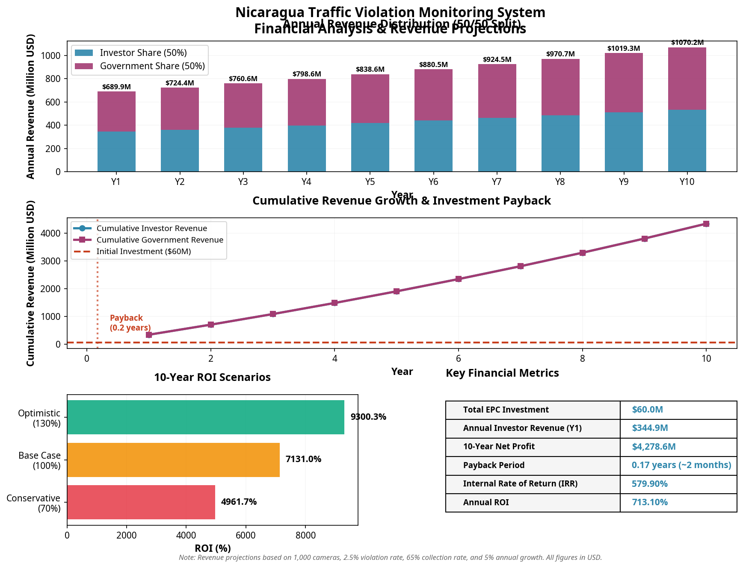 Detailed financial projections showing annual revenue, cumulative growth, ROI scenarios, and key metrics.
Key Financial Highlights (Base Case):
Metric | Value
Total EPC Investment | $60,000,000
Annual Investor Revenue (Year 1) | $344.9 Million
10-Year Net Profit | $4.28 Billion
Return on Investment (ROI) | 7,131%
Payback Period | 0.17 Years (~2 Months)
Internal Rate of Return (IRR) | 579.90%

3.3. Sensitivity Analysis
Even under more conservative assumptions, the project remains highly profitable.
- Conservative Case (70% of base revenue): ROI of 4,962% and a payback period of 0.25 years.
- Optimistic Case (130% of base revenue): ROI of 9,300% and a payback period of 0.13 years.

4. Technical Solution & Deployment Plan

Technical Solution and System Architecture

1. System Overview
The proposed Nationwide Traffic Violation Monitoring System for Nicaragua is a state-of-the-art, integrated solution designed to enhance road safety, improve traffic management, and generate significant revenue through automated enforcement. The system leverages advanced technologies, including AI-powered cameras, real-time data processing, and a centralized management platform.
The architecture is built on a three-tiered model:
- Field Level: A network of intelligent traffic cameras and sensors deployed at strategic locations across the country.
- Network Level: A robust and secure communication network for transmitting violation data from the field to the central platform.
- Central Level: A national control center for data processing, violation validation, fine issuance, and system management.

2. Equipment Specifications (Chinese-Sourced)
The project will exclusively utilize high-quality, cost-effective equipment from leading Chinese manufacturers such as Uniview, Hikvision, or Dahua. This ensures compliance with the project’s requirements while benefiting from competitive pricing and proven technology.

2.1. Intelligent Traffic Enforcement Cameras
- Type: All-in-one AI-powered ANPR (Automatic Number Plate Recognition) cameras.
- Resolution: Minimum 8MP (4K) for high-clarity images and accurate recognition.
- ANPR Accuracy: >98% for Nicaraguan license plates, including motorcycles.
- Violation Detection: Capable of detecting multiple violations simultaneously:
  - Speeding (using integrated radar or video analytics).
  - Red light running.
  - Illegal lane changes.
  - Parking violations.
  - Use of mobile phones while driving.
- Environmental: IP67-rated for dust and water resistance, with a wide operating temperature range suitable for Nicaragua’s climate.
- Data Output: Encrypted video streams and violation data packages (image, video clip, license plate, time, location, violation type).

2.2. Supporting Field Equipment
- Radar Units: Doppler radar units for high-precision speed measurement, integrated with camera systems.
- Illumination: Infrared (IR) and white-light illuminators for 24/7 operation, ensuring clear images at night without distracting drivers.
- Mounting: Vandal-proof poles and enclosures for secure installation.
- Power: Options for both grid and solar power to enable deployment in remote areas.

3. Central Management Platform
A centralized software platform will be the core of the system, providing end-to-end management of the entire workflow.
- Violation Processing: Automated ingestion of violation data, with an AI-powered pre-validation filter.
- Manual Validation Interface: A user-friendly interface for human operators to review and confirm violations before issuing fines.
- Fine Management System: Secure database for managing fines, payment status, and vehicle owner information.
- Data Analytics & Reporting: A powerful dashboard for generating real-time statistics, heatmaps of violation hotspots, and detailed financial reports.
- System Health Monitoring: Proactive monitoring of all field equipment to ensure high uptime and rapid response to maintenance needs.

4. Deployment Strategy
The deployment will be executed in a phased approach to maximize impact and ensure a smooth rollout.
- Phase 1 (Year 1): Deployment of 1,000 camera systems along 2,000 km of the most strategic and high-traffic corridors, including:
  - The Pan-American Highway (NIC-1).
  - Major arteries in Managua.
  - Key routes connecting major cities like León, Granada, and Masaya.
- Phase 2 (Years 2-3): Expansion to secondary highways and other urban centers with high accident rates.
- Phase 3 (Years 4-5): Coverage of remaining paved roads and key rural intersections.
This phased approach allows the system to start generating revenue quickly, funding subsequent expansion and ensuring the project’s long-term sustainability.

5. SINOSURE Guarantee
The entire project, including the EPC investment and the 10-year revenue stream, will be underwritten by the China Export & Credit Insurance Corporation (SINOSURE). This provides an unparalleled level of security for investors, mitigating political and commercial risks and guaranteeing the project’s financial viability.

5. Risk Analysis & Mitigation
Risk | Mitigation Strategy
Political & Regulatory Risk | SINOSURE Guarantee: The project is fully backed by China Export & Credit Insurance Corporation, insuring against political risks, expropriation, and currency inconvertibility. High-Level Government Agreement: Direct partnership with the Nicaraguan government provides stability.
Commercial & Payment Risk | Automated Collection: Fines are linked to mandatory vehicle registrations and renewals, ensuring a high collection rate. SINOSURE Guarantee: Covers risks of non-payment or breach of contract by the government partner.
Technical & Operational Risk | Proven Technology: Utilization of equipment from world-leading Chinese manufacturers (e.g., Uniview) with a strong track record. Comprehensive Maintenance: The financial model includes a significant budget for annual operations and maintenance to ensure high system uptime.
Public Acceptance | Public Safety Campaign: A government-led campaign will highlight the project’s benefits in reducing accidents and saving lives. Fairness and Transparency: The automated system ensures impartial enforcement, removing the potential for human bias or corruption.

6. Conclusion
This project represents a rare confluence of factors: a clear market need, strong government backing, a robust technical solution, and an unparalleled financial guarantee. The investment in Nicaragua’s Nationwide Traffic Violation Monitoring System is not merely a financial venture; it is a nation-building project that will deliver lasting benefits to the country’s safety and infrastructure while providing extraordinary returns to the investor.
We are confident that this is one of the most secure and lucrative infrastructure investment opportunities available in Latin America today. We invite prospective investors to engage with us to discuss this unique opportunity in further detail.

