Investment Proposal: 100MW Solar Photovoltaic Power Plant in Suriname

1. Executive Summary
This report presents a compelling investment opportunity for the development, construction, and operation of a 100-megawatt (MW) utility-scale solar photovoltaic (PV) power plant in Suriname. The project directly addresses the nation’s pressing energy deficit, aligns with the government’s strategic vision for renewable energy expansion, and offers an attractive financial return backed by strong political and financial security.
Suriname is currently facing a significant electricity supply-demand gap, exacerbated by reliance on aging thermal plants and climate-vulnerable hydropower. The government has responded with an ambitious Electricity Sector Plan (2025-2029) that calls for the addition of 195MW of solar capacity by 2029 [1]. This 100MW project represents a cornerstone opportunity to fulfill over 50% of this near-term target, positioning it as a project of national strategic importance.
The project’s viability is underpinned by a confluence of positive factors:
High-Level Support: Direct engagement with the President of Suriname and key ministerial departments has been secured, ensuring streamlined administrative and regulatory processes.
Financial Security: The project is eligible for comprehensive insurance coverage from the China Export & Credit Insurance Corporation (Sinosure), significantly mitigating political and commercial risks for investors.
Proven Technology: The plant will utilize state-of-the-art solar technology, including high-efficiency PV modules and best-in-class smart string inverters from Huawei, a global leader in PV solutions [2].
Favorable Market Conditions: A clear and urgent demand for power, coupled with a government-supported tariff structure, creates a stable and predictable revenue stream.
The total estimated Engineering, Procurement, and Construction (EPC) cost for the project is USD 100 million. Based on a conservative Power Purchase Agreement (PPA) price of USD 0.055 per kWh, the project is projected to generate annual revenues of approximately USD 9.6 million, ensuring a robust return on investment. This proposal outlines the detailed market analysis, technical specifications, and financial projections that establish the project as a secure and profitable venture into the future of sustainable energy in South America.

2. Suriname’s Energy Landscape

2.1. Current Electricity Situation
Suriname’s electricity sector is at a critical juncture. The total installed conventional capacity stands at approximately 522 MW, with an additional 197 MW of renewable capacity, primarily from the Afobaka hydropower plant [3]. However, the system is strained, with a peak demand of 226 MW that is projected to grow significantly to 373 MW by 2030 and 662 MW by 2040 [4].
Table 1: Suriname Electricity Sector - Key Statistics (2023-2024)
Metric | Value | Source
Total Installed Capacity | ~719 MW | [3]
- Conventional (Thermal) | ~522 MW | [3]
- Renewable (Hydro & Solar) | ~197 MW | [3]
System Peak Demand | 226 MW | [4]
Energy Use Per Capita | 1,998 kWh | [3]
Electricity System Losses | 10% | [3]
Recent droughts have impacted the output of the Afobaka dam, which constitutes a significant portion of the country’s baseload power. This has led to an increased reliance on expensive and carbon-intensive thermal generation and resulted in a declared energy crisis in early 2025, with an immediate capacity shortfall of 74 MW [4]. This situation underscores the urgent need for diversification and the rapid deployment of climate-resilient renewable energy sources like solar PV.

2.2. Power Generation Mix
The current energy mix is dominated by fossil fuels and hydropower. Solar PV accounts for less than 1% of the total, presenting a substantial opportunity for growth [5].
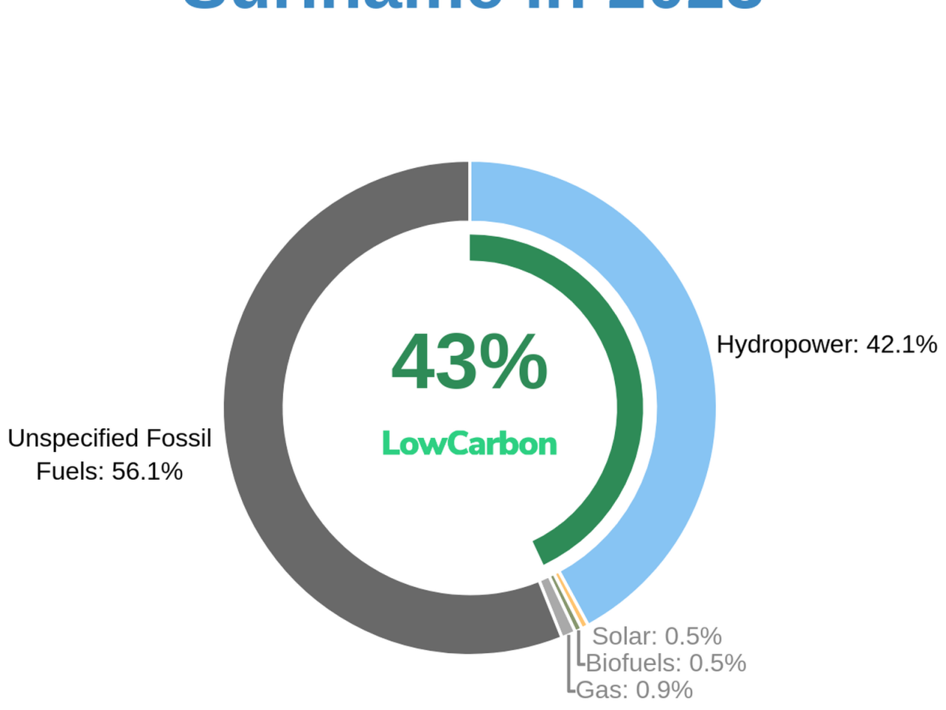 Figure 1: Suriname’s Electricity Generation Mix (2023). Source: Low-Carbon Power [5]

2.3. Government Policy and Tariff Structure
The Government of Suriname has demonstrated a strong commitment to transitioning its energy sector. The Electricity Sector Plan (2025-2029) is the central policy document guiding this transformation. It explicitly calls for the addition of 195 MW of solar PV capacity by 2029, with a total required investment of over USD 425 million in the national grid over the next five years [1].
While a formal feed-in-tariff is still in draft status, the government has established a clear precedent for PPAs with independent power producers (IPPs). The current residential electricity tariff is approximately USD 0.060 per kWh [6]. This provides a strong benchmark for negotiating a long-term PPA for this project, ensuring its financial viability. The project will seek to secure a 20-25 year PPA with the national utility, N.V. Energie Bedrijven Suriname (N.V. EBS).

3. The 100MW Solar PV Project

3.1. Project Overview
The project involves the development of a 100 MWac ground-mounted solar PV power plant. A suitable site with high solar irradiance and proximity to grid infrastructure will be selected in the coastal region, likely within the Wanica or Para districts, to minimize transmission losses and facilitate connection to the main load centers.
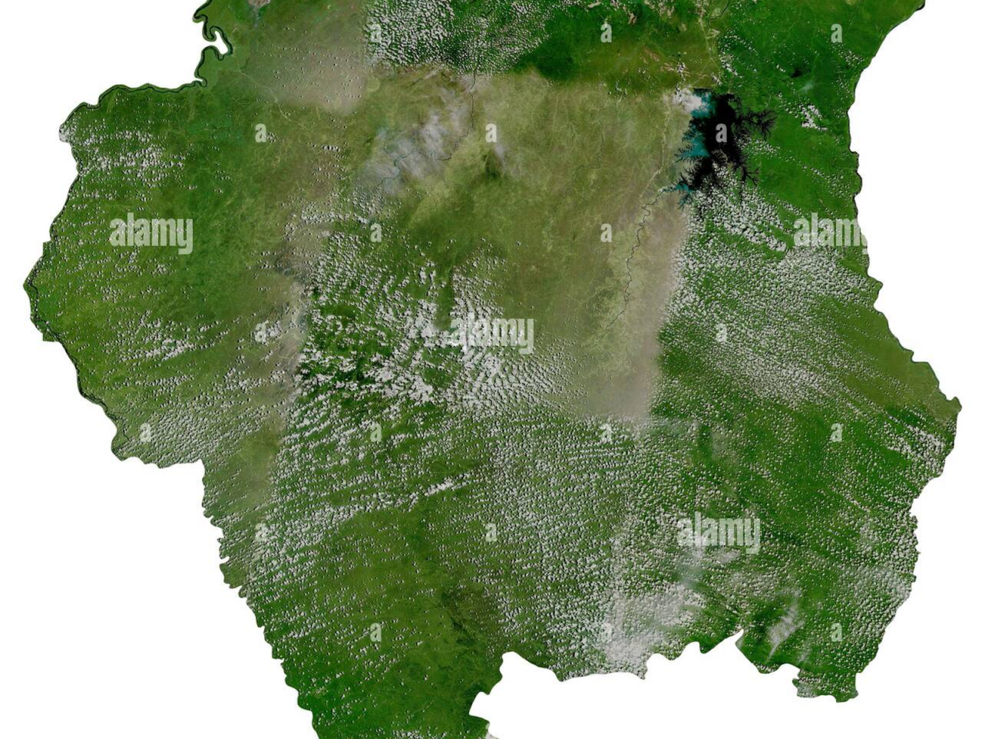 Figure 2: Satellite Map of Suriname. The project will be strategically located near the populated coastal belt.

3.2. Technical Solution
The plant will be designed and built to the highest international standards, ensuring high efficiency, reliability, and a long operational life. The core components include:
- PV Modules: High-efficiency monocrystalline PERC modules will be utilized to maximize energy yield and optimize land use.
- Inverter System: The project will exclusively use Huawei’s SUN2000-330KTL-H1 smart string inverters. These inverters are selected for their high efficiency (99.02% max), advanced safety features, and intelligent O&M capabilities, which reduce operational costs and improve plant performance [2]. Their 12 MPPTs allow for fine-grained optimization, which is ideal for large-scale utility projects.
- Mounting Structure: A fixed-tilt or single-axis tracking system will be evaluated during the detailed engineering phase to determine the optimal balance between cost and energy yield for Suriname’s tropical latitude.
- Grid Connection: The project will include a dedicated substation and transmission line to connect to the N.V. EBS national grid, with all interconnection studies and approvals managed in coordination with the utility and the Energy Authority of Suriname (EAS).

3.3. Project Implementation
The project will be delivered on a turnkey basis through a reputable EPC contractor with a proven track record in utility-scale solar projects in the region. The estimated project timeline from financial close to commercial operation is 18-24 months.

4. Financial Analysis

4.1. EPC Cost Estimate
The total EPC cost is estimated at USD 100 million, or USD 1.00 per watt. This is a comprehensive, all-in cost that includes equipment, civil works, installation, grid connection, and all associated development fees. This figure is in line with current benchmarks for utility-scale solar projects in the Latin American and Caribbean region [7].

4.2. Revenue Projections
Revenue will be generated through the sale of electricity to N.V. EBS under a long-term PPA. Projections are based on the following conservative assumptions:
- Plant Capacity: 100 MWac
- Capacity Factor: 20% (A conservative estimate for a fixed-tilt plant in this region)
- Annual Generation: 100,000 kW * 24 hours/day * 365 days/year * 20% = 175,200,000 kWh
- PPA Price: USD 0.055 per kWh
Annual Revenue = 175,200,000 kWh * USD 0.055/kWh = USD 9,636,000
This stable, contracted revenue stream provides a secure foundation for debt service and investor returns.

4.3. Risk Mitigation
This project has an exceptionally strong risk mitigation framework:
- Political & Commercial Risk: Full coverage from Sinosure provides a robust guarantee against a wide range of potential risks, safeguarding the investment.
- Regulatory Risk: Direct high-level government support ensures a smooth and predictable regulatory pathway.
- Operational Risk: The use of Tier-1 technology from Huawei, coupled with a comprehensive O&M agreement, minimizes technical risks and ensures high plant availability.
- Revenue Risk: A long-term PPA with the national utility provides a fixed, predictable income stream for the life of the project.

5. Conclusion and Investment Ask
The 100MW Suriname Solar PV Project is a shovel-ready, high-impact investment that stands at the intersection of national strategic priority and sound financial logic. It offers a unique opportunity to enter a nascent renewable energy market with the backing of the highest levels of government and the security of a world-class credit insurance agency.
We are seeking USD 100 million in financing to cover the full EPC cost of the project. This investment will not only deliver a stable and attractive financial return but will also contribute significantly to Suriname’s energy security, economic development, and sustainable future.
We invite you to join us in this landmark project to power Suriname’s growth with clean, reliable, and affordable solar energy.

