Investment Proposal: Suriname Nationwide Traffic Violation Monitoring System

1. Executive Summary
This report outlines a lucrative investment opportunity in a nationwide automated traffic violation monitoring system for the Republic of Suriname. The project is structured as a 10-year revenue-sharing Public-Private Partnership (PPP) with the Government of Suriname, offering exceptional returns secured by a guarantee from the China Export & Credit Insurance Corporation (Sinosure). The government has committed to a 50% share of all collected fine revenues for the investor, with the unique provision that all system hardware and software must be procured from designated Chinese manufacturers.
Suriname presents a prime market for this initiative. With a rapidly growing vehicle population that has nearly doubled in the past decade and a concentrated road network, the country is facing increasing traffic congestion and safety challenges [1, 2]. The existing enforcement infrastructure is limited, creating a significant opportunity for a technology-driven solution. This project will introduce a state-of-the-art automated system to enforce traffic laws, enhance road safety, and generate substantial revenue for both the investor and the government.
The total Engineering, Procurement, and Construction (EPC) investment is estimated at $14.76 million USD. Based on conservative projections, the project is expected to generate over $711 million USD in revenue for the investor over the 10-year contract period. This translates to an extraordinary Return on Investment (ROI) of 4,711%, with a remarkably short payback period of just 3.7 months.
The investment is significantly de-risked through several key factors:
- Sinosure Guarantee: The project is backed by China’s official export credit agency, providing comprehensive insurance against political and commercial risks [3].
- High-Level Government Support: The project has received endorsement at the highest levels, with direct access to the President of Suriname and relevant ministries for negotiation and implementation.
- Proven Technology: The system will be built using advanced, reliable, and cost-effective technology from world-leading Chinese manufacturers like Hikvision and Dahua [4].
- Favorable Contract Terms: A 10-year, 50/50 revenue-sharing agreement provides a long-term, stable, and highly profitable income stream.
This proposal details the market analysis, technical solution, comprehensive financial projections, and risk mitigation strategies that make this a secure and exceptionally high-yield investment opportunity.

2. Market Analysis: The Suriname Opportunity
Suriname’s economic and traffic landscape creates a compelling case for the implementation of an automated traffic enforcement system. The analysis of current data reveals a market ripe for this technological intervention.

2.1. Demographics and Vehicle Growth
Suriname, an upper-middle-income country with a population of approximately 613,000, is experiencing significant growth in vehicle ownership [5]. The total number of registered vehicles stood at 244,016 in 2021, a rate of nearly 400 vehicles per 1,000 people. This figure is estimated to have grown to over 270,000 by 2025, with some sources indicating that car ownership has almost doubled in the last decade [1, 6]. This rapid motorization, particularly in the capital city of Paramaribo, has strained the existing road infrastructure, leading to increased traffic congestion and a higher probability of traffic violations.
 A typical traffic scene in Paramaribo, showcasing the density of vehicles on urban roads.

2.2. Road Infrastructure
Suriname’s road network is relatively small and manageable, making a nationwide monitoring system feasible and cost-effective. The key statistics are as follows [2]:
Road Network Characteristic | Value | Note
Total Road Network | 4,304 km
Paved Roads | 1,119 km | (26% of total) - Primary focus for deployment
Major Highways | East-West Link, D.D. Bouterse Highway | Connects key economic zones
Traffic Flow | Left-hand driving | A unique characteristic in the Americas
The majority of traffic is concentrated on the paved road network, especially within the Paramaribo metropolitan area and along the main East-West Link highway. This concentration allows for a strategic deployment of monitoring equipment to cover the vast majority of daily traffic with a limited number of camera installations.

2.3. Existing Legal and Enforcement Framework
The legal framework for traffic enforcement is already in place. The World Health Organization (WHO) reports that Suriname has established national laws for speed limits, seatbelt use, drink-driving, and prohibiting mobile phone use while driving [5].
- Maximum Urban Speed Limit: 40 km/h
- Maximum Rural Speed Limit: 80 km/h
- Drink-Driving BAC Limit: 0.05 g/dl
However, the enforcement of these laws is primarily manual and limited in scope. The introduction of an automated 24/7 monitoring system will not require new legislation but will rather serve as a powerful tool to enforce existing laws effectively and impartially, acting as a significant deterrent to unsafe driving behaviors.

3. Financial Analysis and Projections
The financial model for this project demonstrates its exceptional profitability, driven by a high volume of potential violations and a favorable revenue-sharing agreement. The projections are based on conservative estimates derived from international benchmarks and adjusted for Suriname’s specific context.

3.1. Total EPC Investment
The total turnkey investment required to design, procure, and deploy the nationwide system is $14,760,000 USD. This comprehensive budget includes all hardware, software, installation, project management, and the Sinosure insurance premium.
Category | Amount (USD)
Equipment (Cameras, ANPR, etc.) | $5,400,000
Infrastructure & Installation | $3,575,000
Central Management System & Data Center | $2,380,000
Project Management & Contingency (8%) | $2,700,000
Sinosure Insurance Premium | $705,000
TOTAL EPC INVESTMENT | $14,760,000

3.2. Revenue Projections and ROI
Revenue is generated from fines collected from traffic violations. With a weighted average fine of $60 USD and a phased deployment reaching 300 camera locations, the system is projected to capture a significant number of violations. The collection rate is conservatively estimated to start at 65% and grow to 80% as the system matures.
The 10-year financial forecast highlights the project’s powerful returns:
- Total Investor Revenue (10 Years): $711.2 Million
- Total Investor Net Profit (After OPEX): $695.5 Million
- Return on Investment (ROI): 4,711%
- Payback Period: 3.7 Months
- Internal Rate of Return (IRR): ~580%
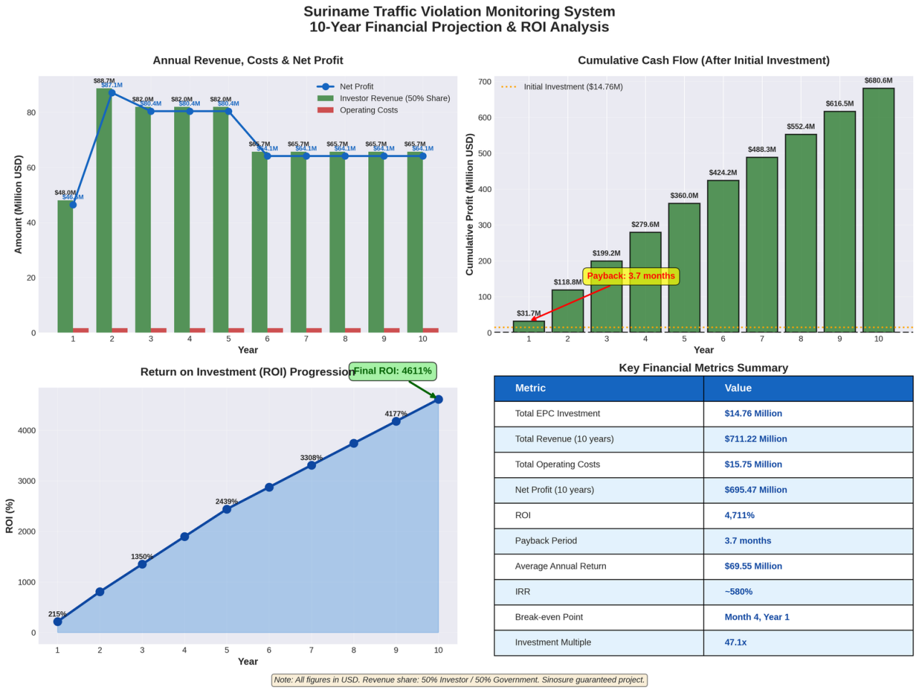 Visual analysis of the 10-year financial projections, detailing revenue, costs, cumulative cash flow, and ROI progression.

3.3. Benefits to the Government of Suriname
This PPP model offers substantial benefits to the Government of Suriname at no upfront cost.
- Direct Revenue: A projected $711.2 million USD in new, direct revenue over 10 years, representing an approximate 7% increase over current total government revenue [7].
- Improved Road Safety: A significant reduction in traffic violations and accidents, leading to fewer fatalities and injuries and lower associated healthcare and infrastructure repair costs.
- Modernized Infrastructure: The government gains a state-of-the-art national traffic management system without any capital expenditure.
- Enhanced Governance: Promotes a culture of law and order on the roads through fair and consistent enforcement.

4. Technical Solution
The proposed system is a robust, scalable, and secure solution built on a multi-tiered architecture. It leverages proven technology from leading Chinese manufacturers to ensure high performance and reliability.

4.1. System Architecture
The architecture is composed of four main tiers:
- Edge Tier: Intelligent cameras and sensors at the roadside for real-time violation detection and evidence capture.
- Network Tier: A secure network using fiber optics and 4G/5G to transmit encrypted data to the central system.
- Core Tier: A central data center for processing violations, managing data, and housing the Network Operations Center (NOC).
- Integration Tier: Secure APIs to connect with government databases (vehicle registration, driver’s licenses) for seamless data exchange.

4.2. Violation Processing Workflow
The workflow is fully automated and designed for legal integrity:
- Detection & Capture: The roadside unit automatically detects a violation and captures encrypted evidence (images, video, data).
- Transmission & Validation: Evidence is securely transmitted and automatically cross-referenced with the vehicle registration database.
- Human Verification: A trained operator reviews the evidence to confirm the violation, ensuring accuracy and preventing false positives.
- Notice Generation & Issuance: The system automatically generates and issues a violation notice to the registered owner.
- Payment & Resolution: The system tracks payment status and automatically closes cases upon successful payment or escalates them for judicial action in cases of non-payment.

5. Risk Assessment and Mitigation
While the potential returns are exceptionally high, a thorough risk assessment has been conducted. The project incorporates a multi-layered strategy to mitigate potential risks.
Risk Category | Description | Mitigation Strategy
Political Risk | Changes in government policy, non-payment by the government, or expropriation. | Sinosure Political Risk Insurance: Provides comprehensive coverage against such events, ensuring the security of the investment. The 10-year binding contract and high-level government support further stabilize the project.
Commercial Risk | Lower-than-expected revenue due to low violation rates or poor collection rates. | Conservative Financial Modeling: Projections already use conservative estimates. Sensitivity analysis shows the project remains highly profitable even with a 50% reduction in revenue. An escrow account for revenue collection ensures transparency and timely distribution.
Technical Risk | Equipment failure, software bugs, or cybersecurity threats. | Tier-1 Chinese Suppliers: Use of proven, high-quality equipment from manufacturers like Hikvision/Dahua minimizes failure rates. A comprehensive maintenance plan and a dedicated technical team will ensure high system uptime. End-to-end encryption and a secure Tier III data center will protect against cyber threats.
Public Acceptance | Public opposition to automated enforcement. | Public Awareness Campaign: A government-led campaign will be launched to educate the public on the road safety benefits of the system. The fairness and transparency of the automated system will help build public trust over time.

6. Conclusion
This investment proposal presents a rare opportunity to participate in a nation-building project that offers both significant social benefits and extraordinary financial returns. The combination of a ready market, strong government partnership, a long-term revenue-sharing contract, and the robust security of a Sinosure guarantee makes the Suriname Nationwide Traffic Violation Monitoring System a uniquely attractive and secure investment.
We invite you to engage with us further to explore the detailed financial models and operational plans for this landmark project.

